Topic 6 revision

[Lesson 1](topic%206/lesson1.pptm)

Photosynthesis

Carbon dioxide is a greenhouse gas. This means it traps heat from the Earth and stops it escaping into space, like a pane of glass in a greenhouse.

Causing global warming

If there is starch, then photosynthesis has taken place (using iodine) turning blue/black

The starch test can be used to prove that photosynthesis needs light, carbon dioxide and chlorophyll to take place.

Variegated leaves have **pale** parts, which do not contain chlorophyll. The green parts of the leaf contain chlorophyll and are the **control**.

Glucose for energy

Chlorophyll absorbs the light and converting it into chemical energy

Chloroplasts are what converts solar energy to molecules?

[LESSON 2](topic%206/lesson2.pptx)

When a process depends on two or more factors, the rate of that process is limited by the factor which is in shortest supply

The rate of photosynthesis in a plant can be limited by:

* Light intensity
* Availability of water
* Availability of carbon dioxide
* Availability of chlorophyll
* Temperature

For plants nutrition = photosynthesis

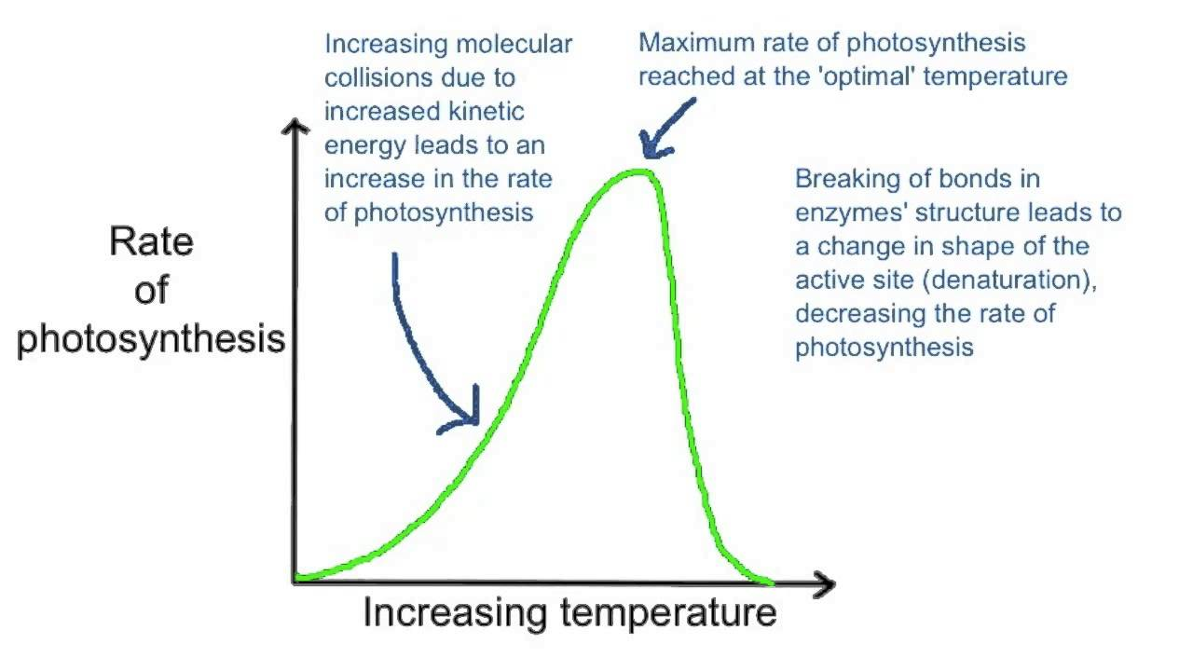

Its just common sense, if there’s 10 buns, 6 burgers, 6 tomatoes, 18 pickles and each burger has to have at least 2 buns, 1 burger, 1 tomato, 3 pickles there’s going to be only 5 burgers.

1. In May to August (summertime) the amount of carbon dioxide in the atmosphere goes down
2. This is because increase in temperature increases the rate of respiration of plants (when temperature is low cellular processes low to conserve energy)

[LESSON 3](topic%206/lesson3.pptx)

The outer layer of the leaf is very thin and is transparent:

This helps the leaf to photosynthesise as it allows sunlight to pass through easily to the cells underneath that contain the chloroplasts.

**Q. Why does the sunlight need to pass easily through to the chloroplasts?**

The surface of the leaf is broad and flat with a **large surface area**.

This means there is a large space for sunlight to get through and reach the cells that contain chloroplasts.

**Q. How would photosynthesis be affected if the leaves were curled up?**

The chloroplasts contain chlorophyll which absorb light energy.

The chlorophyll absorbs the light energy that is needed for photosynthesis.

**Q. How would the number of chloroplasts affect the rate of photosynthesis?**

Pores on the underside of the leaf called STOMATA can open and close to let gases in and out.

This allows carbon dioxide to reach the cells for photosynthesis and allows oxygen to leave the leaf after photosynthesis.

[link](topic%206/lesson3.pptx) for the other ones

[Lesson 4](topic%206/lesson4.pptx)

Photosynthesis happens sometimes/ respiration happens all the time

Like humans eat food sometimes/ but constantly breathe

In the **light** photosynthesis>respiration rate so net gas exchange is co2 into and oxygen out

Hydrogen carbonate – co2 = lower co2 concentration

At **dawn** compensation point cause rate of respiration and photosynthesis are equal/ no net change

**In the dark** respiration is more than photosynthesis so net change is respiration +. So, the only thing happening is oxygen entering and co2 leaving leave hence less co2. Red to yellow.

Photosynthesis lessens co2 and increases O

Respiration increases co2 and decreases O

[Lesson 6](topic%206/lesson6.pptx)